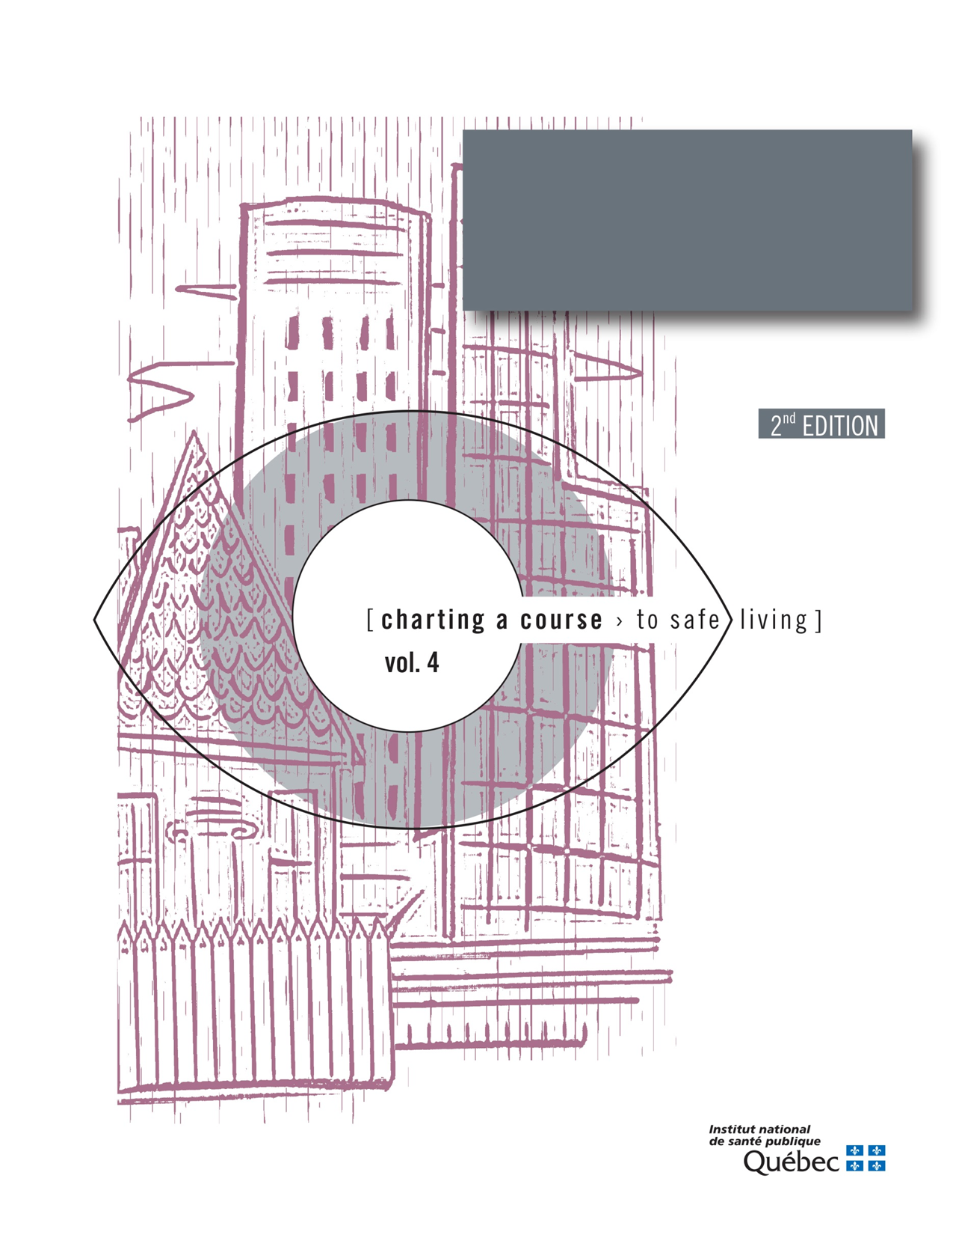

Guide to Analysing Spousal Violence withing a Region
Appendix 1
REQUEST FORM FOR STATISTICS FROM THE MINISTÈRE DE LA SÉCURITÉ PUBLIQUE ON CRIMES COMMITTED IN A SPOUSAL CONTEXT

- INFORMATION ON THE PERSON MAKING THE REQUEST
NAME:
BODY:
CONTACT INFORMATION:
PURPOSE OR CONTEXT OF THE REQUEST:

NOTE: Once you have filled out the request form, you can e-mail it to the MSP at dps-statistique@msp.gouv.qc.ca. The MSP will process the request within four weeks.

Note that data extracted from the UCR2 Survey for a year prior to the request remain preliminary until data have been extracted for a subsequent year, at which point the prior year data are updated. Prior year data remain preliminary until that time mainly because of the impacts of the judicial and police process or because of errors related to system operation. Preliminary data are subject to change and must be interpreted with caution.

INFORMATION ON THE STUDY AREA

- ADMINISTRATIVE REGIONS

Select the administrative regions and, if applicable, the regional county municipalities (RCMs) that you would like to include in your analysis. For administrative purposes, the official French name (i.e., “MRC”) of each RCM is used in the form.

Bas-Saint-Laurent (01)
MRC
MRC de Kamouraska
MRC de la Matapédia
MRC de la Mitis
MRC de Matane
MRC de Rimouski-Neigette
MRC de Rivière-du-Loup
MRC de Témiscouata
MRC des Basques
Saguenay-Lac-Saint-Jean (02)
MRC
MRC de Lac-Saint-Jean-Est
MRC de Maria-Chapdelaine
MRC du Domaine-du-Roy
MRC du Fjord-Du-Saguenay
Capitale-Nationale (03)
MRC
MRC de Charlevoix
MRC de Charlevoix-Est
MRC de la Côte-de-Beaupré
MRC de la Jacques-Cartier
MRC de l’Île-d’Orléans
MRC de Portneuf

Centre-du-Québec (04)
MRC
MRC d’Arthabaska
MRC de Bécancour
MRC de Drummond
MRC de l’Érable
MRC de Nicolet-Yamaska

Estrie (05)
MRC
MRC de Coaticook
MRC de Memphrémagog
MRC des Sources
MRC du Granit
MRC du Haut-Saint-François
MRC du Val-Saint-François
Montréal (06)
Outaouais (07)
MRC
MRC de la Vallée-de-la-Gatineau
MRC de Papineau
MRC de Pontiac
MRC des Collines-de-l’Outaouais
Abitibi-Témiscamingue (08)
MRC
MRC de l’Abitibi
MRC de l’Abitibi-Ouest
MRC de la Vallée-de-l’Or
MRC de Témiscamingue

Côte-Nord (09)
MRC
MRC de Caniapiscau
MRC de la Haute-Côte-Nord
MRC de la Manicouagan
MRC de Minganie
MRC des Sept-Rivières
MRC du Golfe-du-Saint-Laurent

Nord-du-Québec (10)
MRC
Kativik
Jasémie
Eeyou Istchee (nouveau toponyme à venir)

Gaspésie-Îles-de-la-Madeleine (11)
MRC
Les Îles-de-la-Madeleine
MRC d’Avignon
MRC de Bonaventure
MRC de la Côte-de-Gaspé
MRC de la Haute-Gaspésie
MRC du Rocher-Percé

Chaudière-Appalaches (12)
MRC
MRC de Beauce-Sartigan
MRC de Bellechasse
MRC de la Nouvelle-Beauce
MRC de L’Islet
MRC de Lotbinière
MRC de Montmagny
MRC des Appalaches
MRC des Etchemins
MRC Robert-Cliche

Laval (13)
Lanaudière (14)
MRC
MRC de D’autray
MRC de Joliette
MRC de l’Assomption
MRC de Matawinie
MRC de Montcalm
MRC des Moulins

Laurentides (15)
MRC
MRC d’Antoine-Labelle
MRC d’Argenteuil
MRC de Deux-Montagnes
MRC de la Rivière-du-Nord
MRC des Laurentides
MRC des Pays-d’en-Haut
MRC Thérèse-De Blainville

Montérégie (16)
MRC
MRC d’Acton
MRC de Beauharnois-Salaberry
MRC de Brome-Missisquoi
MRC de la Haute-Yamaska
MRC de la Vallée-du-Richilieu
MRC de Marguerite-D’Youville
MRC de Roussillon
MRC de Rouville
MRC de Vaudreuil-Soulanges
MRC des Jardins-de-Napierville
MRC des Maskoutains
MRC du Haut-Richilieu
MRC du Haut-Saint-Laurent
MRC de Pierre-De Saurel

Mauricie (17)
MRC
MRC de Maskinongé
MRC de Mékinac
MRC des Chenaux

Census metropolitan area (CMA)
Montréal
Québec
Ottawa - Gatineau (part of Québec)
Sherbrooke
Saguenay
Trois-Rivières

Québec as a whole

STATISTICS

NATURE OF THE OFFENCES COMMITTED
Number of offences
Offence rate

Type of offences committed in a spousal context
Select one of more offences

General intimidation
Forcible confinement
Kidnapping
Sexual assault
Level 1 assault
Level 2 assault
Level 3 assault
Criminal harassment
Homicide
Threats
Indecent or harassing telephone calls
All of these offences

CHANGE
Table on the number of offences
Chart on the offence rate

Select the period

Last five (5) years
Last ten (10) years

In the following sections, note only those years for which updated data will be used for the analysis.
PERIOD
Select the desired years

The most recent year
The most recent year and the previous year

AGE GROUPS OF VICTIMS
Number of victims
Distribution of victims (%)
Victim rate

Check the age groups that need to be analyzed
12 to 17  18 to 24  25 to 29  30 to 39 | 40 to 49  50 to 59  60 to 69  70 and over  Other, specify
AGE GROUPS OF ACCUSED PERSONS
Number of accused persons
Distribution of accused persons (%)
Rate of accused persons

Check the age groups that need to be analyzed
12 to 17  18 to 24  25 to 29  30 to 39 | 40 to 49  50 to 59  60 to 69  70 and over  Other, specify
NATURE OF THE RELATIONSHIP BETWEEN VICTIMS AND ACCUSED PERSONS, including the notion of same-sex spouse
Number of victims  Distribution of victims (%)  Current spouse  Former spouse | Current intimate friend  Former intimate friend

VICTIMS BY GENDER
Number of victims
Distribution of victims (%)
Victim rate

Do you want to obtain statistics on females, males or both?

Females
Males

ACCUSED PERSONS BY GENDER

Number of accused persons
Distribution of accused persons (%)
Rate of accused persons

Do you want to obtain statistics on females, males or both?

Females
Males

CROSS-MATCHING OF VARIABLES
Number
Distribution (%)
Rate

Which variables do you want to cross-match in this analysis?

Type of offence and gender
Type of offence and age
Type of offence and nature of the relationship between the accused person and the victim
Gender of victims and age
Gender of accused persons and age
Other, specify

A census metropolitan area is an area consisting of one or more neighbouring municipalities situated around a core. A census metropolitan area must have a total population of at least 100,000 of which 50,000 or more live in the core. (Statistics Canada (Retrieved on December 8, 2014). Census metropolitan area (CMA) and census agglomeration (CA), [online], http://www12.statcan.gc.ca/census-recensement/2011/ref/dict/geo009-eng.cfm).
The ministère de la Sécurité publique reserves the right to choose the most recent year for which data have been updated in order to obtain more reliable statistics.
Note that the more variables and the more cross-matching of variables included in your request, the more complex the statistical analysis may be.
Note that the offence rate is not available for cross-matching these variables.

